31. FIFO Page Replacement
Aim:
To construct a C program to simulate the First In First Out (FIFO) paging technique of memory management.
Program:
#include <stdio.h>

int main()
{
int pages[50], frames[10];
int n, f, i, j, k = 0;
int pageFaults = 0, pageHits = 0;
int found;

printf("Enter number of pages: ");
scanf("%d", &n);

printf("Enter the page reference string:\n");
for (i = 0; i < n; i++)
scanf("%d", &pages[i]);

printf("Enter number of frames: ");
scanf("%d", &f);

for (i = 0; i < f; i++)
frames[i] = -1;

printf("\nPage\tFrames\n");

for (i = 0; i < n; i++)
{
found = 0;

for (j = 0; j < f; j++)
{
if (frames[j] == pages[i])
{
found = 1;
break;
}
}

if (found)
{
pageHits++;
}
else
{
frames[k] = pages[i];
k = (k + 1) % f;
pageFaults++;
}

printf("%d\t", pages[i]);

for (j = 0; j < f; j++)
{
if (frames[j] == -1)
printf("- ");
else
printf("%d ", frames[j]);
}

printf("\n");
}

printf("\nTotal Page Faults = %d\n", pageFaults);
printf("Total Page Hits = %d\n", pageHits);

return 0;
}
Sample Input:
Enter number of pages: 12
Enter the page reference string:
1 2 3 4 1 2 5 1 2 3 4 5
Enter number of frames: 3
Sample Output:
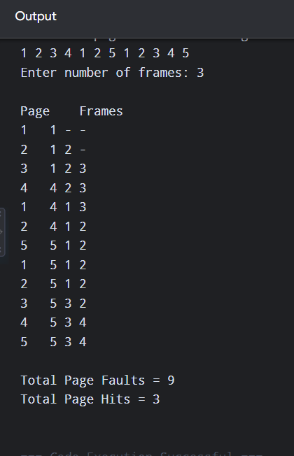
Result:
Thus, the FIFO page replacement technique was successfully simulated.

32. Least Recently Used (LRU) Page Replacement
Aim:
To construct a C program to simulate the Least Recently Used (LRU) paging technique of memory management.
Program:
#include <stdio.h>

int main()
{
int pages[50], frames[10], recent[10];
int n, f, i, j, k;
int pageFaults = 0, pageHits = 0;
int found, pos, least;

printf("Enter number of pages: ");
scanf("%d", &n);

printf("Enter the page reference string:\n");
for (i = 0; i < n; i++)
scanf("%d", &pages[i]);

printf("Enter number of frames: ");
scanf("%d", &f);

for (i = 0; i < f; i++)
{
frames[i] = -1;
recent[i] = -1;
}

printf("\nPage\tFrames\n");

for (i = 0; i < n; i++)
{
found = 0;

for (j = 0; j < f; j++)
{
if (frames[j] == pages[i])
{
found = 1;
recent[j] = i;
break;
}
}

if (found)
{
pageHits++;
}
else
{
pos = -1;

for (j = 0; j < f; j++)
{
if (frames[j] == -1)
{
pos = j;
break;
}
}

if (pos == -1)
{
least = recent[0];

for (j = 1; j < f; j++)
{
if (recent[j] < least)
{
least = recent[j];
pos = j;
}
}
}

frames[pos] = pages[i];
recent[pos] = i;
pageFaults++;
}

printf("%d\t", pages[i]);

for (k = 0; k < f; k++)
{
if (frames[k] == -1)
printf("- ");
else
printf("%d ", frames[k]);
}

printf("\n");
}

printf("\nTotal Page Faults = %d\n", pageFaults);
printf("Total Page Hits = %d\n", pageHits);

return 0;
}
Sample Input:
Enter number of pages: 12
Enter the page reference string:
1 2 3 4 1 2 5 1 2 3 4 5
Enter number of frames: 3
Sample Output:
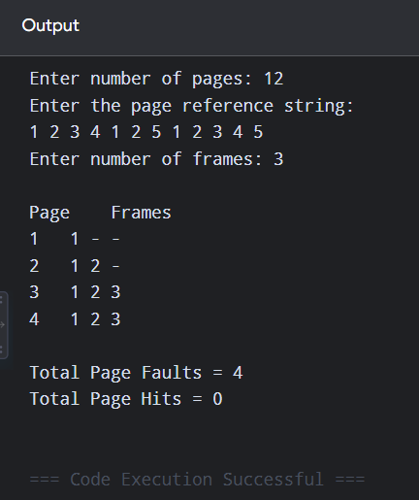
Result:
Thus, the LRU page replacement technique was successfully simulated.

33. Optimal Page Replacement
Aim:
To construct a C program to simulate the Optimal paging technique of memory management.
Program:
#include <stdio.h>

int main()
{
int pages[50], frames[10];
int n, f, i, j, k;
int found, pos, farthest, next;

int pageFaults = 0, pageHits = 0;

printf("Enter number of pages: ");
scanf("%d", &n);

printf("Enter the page reference string:\n");
for (i = 0; i < n; i++)
scanf("%d", &pages[i]);

printf("Enter number of frames: ");
scanf("%d", &f);

for (i = 0; i < f; i++)
frames[i] = -1;

printf("\nPage\tFrames\n");

for (i = 0; i < n; i++)
{
found = 0;

for (j = 0; j < f; j++)
{
if (frames[j] == pages[i])
{
found = 1;
break;
}
}

if (found)
{
pageHits++;
}
else
{
pos = -1;

for (j = 0; j < f; j++)
{
if (frames[j] == -1)
{
pos = j;
break;
}
}

if (pos == -1)
{
farthest = -1;

for (j = 0; j < f; j++)
{
next = n + 1;

for (k = i + 1; k < n; k++)
{
if (frames[j] == pages[k])
{
next = k;
break;
}
}

if (next > farthest)
{
farthest = next;
pos = j;
}
}
}

frames[pos] = pages[i];
pageFaults++;
}

printf("%d\t", pages[i]);

for (j = 0; j < f; j++)
{
if (frames[j] == -1)
printf("- ");
else
printf("%d ", frames[j]);
}

printf("\n");
}

printf("\nTotal Page Faults = %d\n", pageFaults);
printf("Total Page Hits = %d\n", pageHits);

return 0;
}
Sample Input:
Enter number of pages: 12
Enter the page reference string:
1 2 3 4 1 2 5 1 2 3 4 5
Enter number of frames: 3
Sample Output:
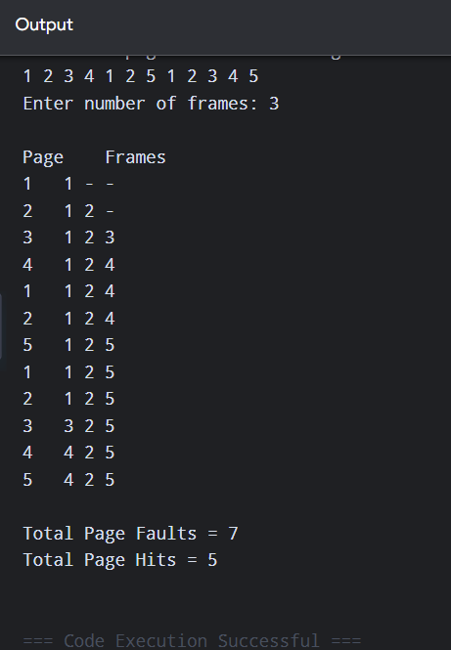
Result:
Thus, the Optimal page replacement technique was successfully simulated.

34. Sequential File Allocation
Aim:
To design a C program to simulate the sequential file allocation strategy.
Program:
#include <stdio.h>

int main()
{
int start, length, i;

printf("Enter starting block: ");
scanf("%d", &start);

printf("Enter number of blocks required: ");
scanf("%d", &length);

printf("\nFile is allocated sequentially.\n");
printf("Block numbers allocated:\n");

for (i = 0; i < length; i++)
printf("%d ", start + i);

printf("\n");

return 0;
}
Sample Input:
Enter starting block: 10
Enter number of blocks required: 6
Sample Output:
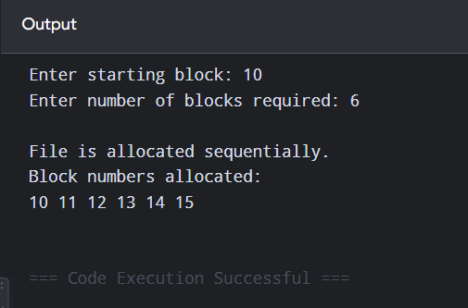
Result:
Thus, the sequential file allocation strategy was successfully simulated.

35. Indexed File Allocation
Aim:
To design a C program to simulate the indexed file allocation strategy.
Program:
#include <stdio.h>

int main()
{
int indexBlock, n, blocks[50];
int i;

printf("Enter index block number: ");
scanf("%d", &indexBlock);

printf("Enter number of file blocks: ");
scanf("%d", &n);

printf("Enter the file block numbers:\n");

for (i = 0; i < n; i++)
scanf("%d", &blocks[i]);

printf("\nIndex Block: %d\n", indexBlock);
printf("Index Block Contents:\n");

for (i = 0; i < n; i++)
printf("Entry %d -> Block %d\n", i + 1, blocks[i]);

return 0;
}
Sample Input:
Enter index block number: 5
Enter number of file blocks: 5
Enter the file block numbers:
12 8 20 15 30
Sample Output:
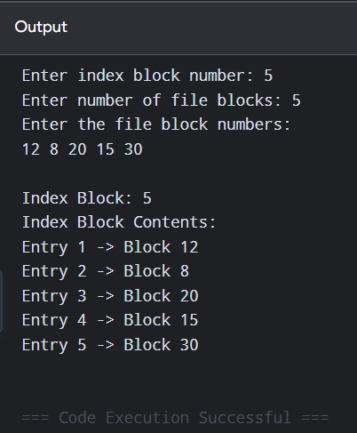
Result:
Thus, the indexed file allocation strategy was successfully simulated.

36. Linked File Allocation
Aim:
To design a C program to simulate the linked file allocation strategy.
Program:
#include <stdio.h>

int main()
{
int n, blocks[50];
int i;

printf("Enter number of blocks in the file: ");
scanf("%d", &n);

printf("Enter the block numbers:\n");

for (i = 0; i < n; i++)
scanf("%d", &blocks[i]);

printf("\nLinked File Allocation:\n");

printf("First Block = %d\n", blocks[0]);
printf("Last Block = %d\n", blocks[n - 1]);

printf("\nBlock Chain:\n");

for (i = 0; i < n - 1; i++)
printf("%d -> ", blocks[i]);

printf("%d -> NULL\n", blocks[n - 1]);

return 0;
}
Sample Input:
Enter number of blocks in the file: 6
Enter the block numbers:
9 16 1 25 10 18
Sample Output:
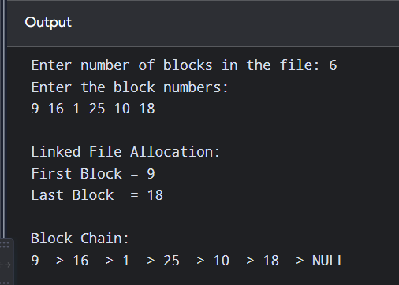
Result:
Thus, the linked file allocation strategy was successfully simulated.

37. FCFS Disk Scheduling
Aim:
To construct a C program to simulate the First Come First Served (FCFS) disk scheduling algorithm.
Program:
#include <stdio.h>
#include <stdlib.h>

int main()
{
int request[50], n, head;
int i, total = 0;

printf("Enter number of disk requests: ");
scanf("%d", &n);

printf("Enter disk request queue:\n");
for (i = 0; i < n; i++)
scanf("%d", &request[i]);

printf("Enter initial head position: ");
scanf("%d", &head);

printf("\nSeek Sequence:\n");
printf("%d", head);

for (i = 0; i < n; i++)
{
total += abs(request[i] - head);
head = request[i];

printf(" -> %d", head);
}

printf("\n\nTotal Head Movement = %d cylinders\n", total);

return 0;
}
Sample Input:
Enter number of disk requests: 8
Enter disk request queue:
98 183 37 122 14 124 65 67
Enter initial head position: 53
Sample Output:
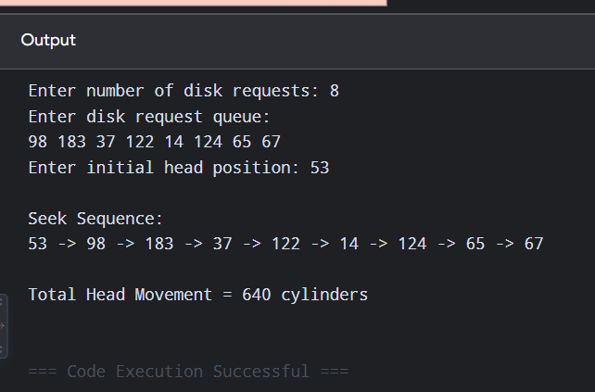
Result:
Thus, the FCFS disk scheduling algorithm was successfully simulated.

38. SCAN Disk Scheduling
Aim:
To design a C program to simulate the SCAN disk scheduling algorithm.
Program:
#include <stdio.h>
#include <stdlib.h>

void sort(int a[], int n)
{
int i, j, temp;

for (i = 0; i < n - 1; i++)
{
for (j = i + 1; j < n; j++)
{
if (a[i] > a[j])
{
temp = a[i];
a[i] = a[j];
a[j] = temp;
}
}
}
}

int main()
{
int request[50], n, head, diskSize;
int i, pos, total = 0;

printf("Enter disk size: ");
scanf("%d", &diskSize);

printf("Enter number of requests: ");
scanf("%d", &n);

printf("Enter request queue:\n");
for (i = 0; i < n; i++)
scanf("%d", &request[i]);

printf("Enter initial head position: ");
scanf("%d", &head);

sort(request, n);

printf("Enter direction (1 for right, 0 for left): ");
scanf("%d", &pos);

printf("\nSeek Sequence:\n");
printf("%d", head);

if (pos == 1)
{
for (i = 0; i < n; i++)
{
if (request[i] >= head)
{
total += abs(request[i] - head);
head = request[i];
printf(" -> %d", head);
}
}

total += abs((diskSize - 1) - head);
head = diskSize - 1;
printf(" -> %d", head);

for (i = n - 1; i >= 0; i--)
{
if (request[i] < head)
{
total += abs(request[i] - head);
head = request[i];
printf(" -> %d", head);
}
}
}
else
{
for (i = n - 1; i >= 0; i--)
{
if (request[i] <= head)
{
total += abs(request[i] - head);
head = request[i];
printf(" -> %d", head);
}
}

total += head;
head = 0;
printf(" -> %d", head);

for (i = 0; i < n; i++)
{
if (request[i] > head)
{
total += abs(request[i] - head);
head = request[i];
printf(" -> %d", head);
}
}
}

printf("\n\nTotal Head Movement = %d cylinders\n", total);

return 0;
}
Sample Input:
Enter disk size: 200
Enter number of requests: 8
Enter request queue:
98 183 37 122 14 124 65 67
Enter initial head position: 53
Enter direction (1 for right, 0 for left): 1
Sample Output:
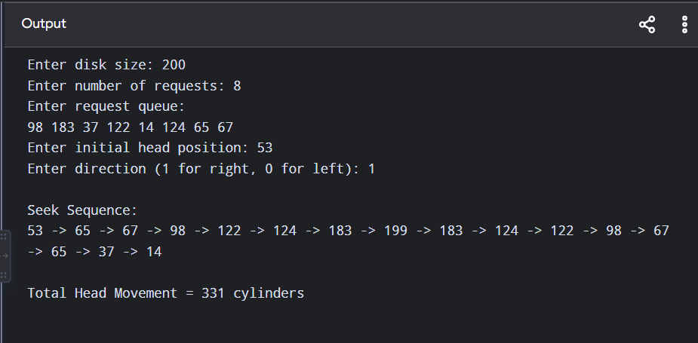
Result:
Thus, the SCAN disk scheduling algorithm was successfully simulated.

39. C-SCAN Disk Scheduling
Aim:
To develop a C program to simulate the C-SCAN disk scheduling algorithm.
Program:
#include <stdio.h>
#include <stdlib.h>

void sort(int a[], int n)
{
int i, j, temp;

for (i = 0; i < n - 1; i++)
{
for (j = i + 1; j < n; j++)
{
if (a[i] > a[j])
{
temp = a[i];
a[i] = a[j];
a[j] = temp;
}
}
}
}

int main()
{
int request[50], n, head, diskSize;
int i, total = 0;

printf("Enter disk size: ");
scanf("%d", &diskSize);

printf("Enter number of requests: ");
scanf("%d", &n);

printf("Enter request queue:\n");
for (i = 0; i < n; i++)
scanf("%d", &request[i]);

printf("Enter initial head position: ");
scanf("%d", &head);

sort(request, n);

printf("\nSeek Sequence:\n");
printf("%d", head);

/* Move towards higher numbered cylinders */
for (i = 0; i < n; i++)
{
if (request[i] >= head)
{
total += abs(request[i] - head);
head = request[i];
printf(" -> %d", head);
}
}

/* Move to the end of disk */
total += abs((diskSize - 1) - head);
head = diskSize - 1;
printf(" -> %d", head);

/* Jump to beginning */
total += diskSize - 1;
head = 0;
printf(" -> %d", head);

/* Continue servicing requests */
for (i = 0; i < n; i++)
{
if (request[i] < head)
{
total += abs(request[i] - head);
head = request[i];
printf(" -> %d", head);
}
}

printf("\n\nTotal Head Movement = %d cylinders\n", total);

return 0;
}
Sample Input:
Enter disk size: 200
Enter number of requests: 8
Enter request queue:
98 183 37 122 14 124 65 67
Enter initial head position: 53
Sample Output:
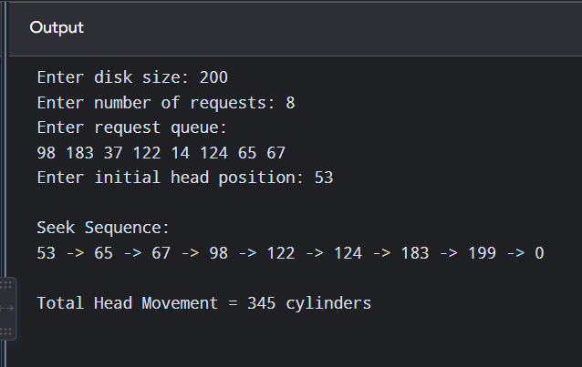
Result:
Thus, the C-SCAN disk scheduling algorithm was successfully simulated.

40. C Program: File Access Permissions and Types of Users in Linux
Aim
To write a C program to illustrate the various file access permissions and different types of users in Linux.
Program
#include <stdio.h>
#include <sys/stat.h>
#include <pwd.h>
#include <unistd.h>

int main()
{
char filename[100];
struct stat file;

printf("Enter the file name: ");
scanf("%s", filename);

if (stat(filename, &file) != 0)
{
printf("File does not exist.\n");
return 1;
}

printf("\nFile: %s\n", filename);

printf("\nFile Access Permissions:\n");

printf("Owner: ");
printf("%c", (file.st_mode & S_IRUSR) ? 'r' : '-');
printf("%c", (file.st_mode & S_IWUSR) ? 'w' : '-');
printf("%c", (file.st_mode & S_IXUSR) ? 'x' : '-');

printf("\nGroup: ");
printf("%c", (file.st_mode & S_IRGRP) ? 'r' : '-');
printf("%c", (file.st_mode & S_IWGRP) ? 'w' : '-');
printf("%c", (file.st_mode & S_IXGRP) ? 'x' : '-');

printf("\nOthers: ");
printf("%c", (file.st_mode & S_IROTH) ? 'r' : '-');
printf("%c", (file.st_mode & S_IWOTH) ? 'w' : '-');
printf("%c", (file.st_mode & S_IXOTH) ? 'x' : '-');

printf("\n\nTypes of Users in Linux:\n");
printf("1. Owner - User who owns the file\n");
printf("2. Group - Users belonging to the file's group\n");
printf("3. Others - All other users\n");

printf("\nPermission symbols:\n");
printf("r - Read\n");
printf("w - Write\n");
printf("x - Execute\n");
printf("- - No permission\n");

return 0;
}
Sample Input
Enter the file name: test.txt
Sample Output
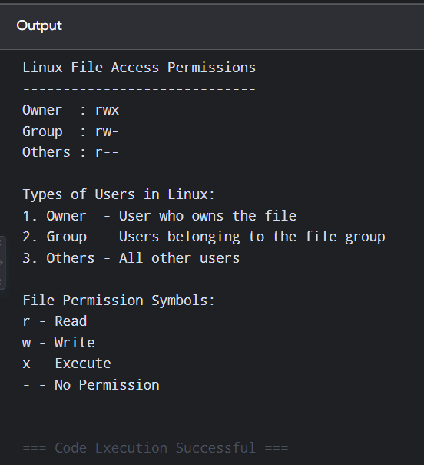
Result
Thus, the C program successfully illustrates the file access permissions (read, write, execute) for owner, group, and others in Linux.

